**Project Management Documentation**

**Code of Conduct:**

**Respect:** All team members should conduct themselves with a high level of respect professionalism. There will be no toleration to disrespectful conduct, including harassment or discrimination.

**Responsibility:** All team members will be accountable for completing their allocated tasks to the best of their abilities and on scheduled timing. Members should inform the group manager as soon as possible if they will not be able to finish a task by the deadline.

**Collaboration:** All team members should work together effectively when needed as it is essential to the project's success. Each member should be eager to assist and aid other member.

**Communication**: A good level of communication is crucial for the project to be successfully completed. All members should strive to communicate in an attentive, and clear manner. Members should communicate with one another frequently, as well as communicating with the project manager.

**Attendance and Absence:** All team members should attend all set meetings. Frequent absence of group members in meetings would lead to involving module tutors and teaching staff.

**Meeting Procedures:** Meetings shall take place biweekly on Northumbrias campus, meetings should consist of providing updates on work, issues ran into and progress. Meetings will usually take between 30-60 minutes.

**Confidentiality:** All team members should maintain the confidentiality of any sensitive information pertaining to the project, and they should not disclose sensitive information to anyone outside the group without the permission from all group members.

**Accountability:** All team members will be held responsible for their choices and actions done. Members should accept responsibility for mistakes they make and attempt to resolve the issue.

**Professionalism:** All team members should act professionally at all times while interacting with other team members and members of staff. This entails arriving on time, keeping to deadlines, and delivering work of high quality.

**Commitment:** All team members should have a high level of commitment to the project and are expected to complete personal and group missions to the best of their abilities.

**Conflict:** All team members are expected to adhere to a professional manner when/if conflicts arise. Project manager should be notified if a conflict occurs, and team members should work together to resolve conflicts. If group cannot resolve a conflict, a vote will be done with the majority vote winning. If vote remains at a 50/50 split, project manager will have final say.

**Ethical Conduct:** All team members are expected to adhere to the university’s ethical standards throughout their work, any form of unethical behavior will not be tolerated. Furthermore, all team members should be treated in a fair and ethical manner.

**Group Member Signatures:**

Signed:

Mohammed Chtiar

Signed:

Abdullah Musleh

Signed:

Syed Quadri

Signed:

Mohamed Etri

**Skills Audits:**

**Skills Audit:**

|  |  |  |  |  |  |
| --- | --- | --- | --- | --- | --- |
| Student name: Abdullah Musleh |  |  |  |  |  |
| Skill | I do not know how to do this | I have some idea how to do this, but need to develop my skills | I can do this, but need more practise | I am comfortable doing this | I am skilled in this |
| Score | 1 | 2 | 3 | 4 | 5 |
| Written Communication |  |  |  |  | X |
| Literature Reviewing |  |  |  | X |  |
| Programming (general) |  |  |  |  | X |
| Programming AI applications |  |  |  | X |  |
| Creative problem solving |  |  |  |  | X |
| Solution design description |  |  |  | X |  |
| Iterative development of AI |  |  |  | X |  |
| Solution testing |  |  | X |  |  |
| Project Management |  |  |  |  | X |
| Maths for AI |  | X |  |  |  |
| Critical Evaluation |  |  |  | X |  |
| API design and creation |  | X |  |  |  |
| UI design and creation |  |  |  | X |  |
| Putting forward suggestions in team meetings |  |  |  |  | X |
| Putting forward suggestions by email/text/etc |  |  |  |  | X |

**Brief Commentary on Strengths and Weaknesses**

I can say that I am quite comfortable managing the project and want to do so, furthermore I am skilled in communicating effectively, solving problems, evaluation and in programming. But I have a weak point in mathematics, so I aim to stir clear from that part of the project. I also don’t feel comfortable designing and creating APIs for the project.

|  |  |  |  |  |  |
| --- | --- | --- | --- | --- | --- |
| Student name: Mohamed Etri |  |  |  |  |  |
| Skill | I do not know how to do this | I have some idea how to do this, but need to develop my skills | I can do this, but need more practise | I am comfortable doing this | I am skilled in this |
| Score | 1 | 2 | 3 | 4 | 5 |
| Written Communication |  |  |  | X |  |
| Literature Reviewing |  |  |  | X |  |
| Programming (general) |  |  | X |  |  |
| Programming AI applications |  |  | X |  |  |
| Creative problem solving |  |  | X |  |  |
| Solution design description |  |  |  | X |  |
| Iterative development of AI |  |  | X |  |  |
| Solution testing |  |  | X |  |  |
| Project Management |  |  |  | X |  |
| Maths for AI |  |  |  | X |  |
| Critical Evaluation |  |  | X |  |  |
| API design and creation | X |  |  |  |  |
| UI design and creation |  |  | X |  |  |
| Putting forward suggestions in team meetings |  |  |  |  | X |
| Putting forward suggestions by email/text/etc |  |  |  |  | X |

**Brief Commentary on Strengths and Weaknesses**

I have very strong communication skills as well as mathematical problem solving skills, I contribute to this team by putting forward suggestions for certain problems we have as we build this project. My weaknesses are building sophisticated code that implements certain functions, I don’t know how to create API or how to design it.

|  |  |  |  |  |  |
| --- | --- | --- | --- | --- | --- |
| Student name: Syed W. Quadri |  |  |  |  |  |
| Skill | I do not know how to do this | I have some idea how to do this, but need to develop my skills | I can do this, but need more practise | I am comfortable doing this | I am skilled in this |
| Score | 1 | 2 | 3 | 4 | 5 |
| Written Communication |  |  | X |  |  |
| Literature Reviewing |  |  | X |  |  |
| Programming (general) |  |  |  |  | X |
| Programming AI applications |  |  |  | X |  |
| Creative problem solving |  |  |  | X |  |
| Solution design description |  |  | X |  |  |
| Iterative development of AI |  |  | X |  |  |
| Solution testing |  |  | X |  |  |
| Project Management |  |  | X |  |  |
| Maths for AI |  |  |  | X |  |
| Critical Evaluation |  |  | X |  |  |
| API design and creation |  |  |  | X |  |
| UI design and creation |  |  |  | X |  |
| Putting forward suggestions in team meetings |  |  |  | X |  |
| Putting forward suggestions by email/text/etc |  |  |  | X |  |

**Brief Commentary on Strengths and Weaknesses**

I have very strong skills in programming and I aim to implement my skillsets in this project. Furthermore, I have a good sense of creativeness and communication that I will use throughout the work. I would say that I would not prefer to critically evaluate or plan and manage this project.

|  |  |  |  |  |  |
| --- | --- | --- | --- | --- | --- |
| Student name: Mohammed Chtiar |  |  |  |  |  |
| Skill | I do not know how to do this | I have some idea how to do this, but need to develop my skills | I can do this, but need more practise | I am comfortable doing this | I am skilled in this |
| Score | 1 | 2 | 3 | 4 | 5 |
| Written Communication |  |  |  | X |  |
| Literature Reviewing |  |  | X |  |  |
| Programming (general) |  |  |  | X |  |
| Programming AI applications |  |  | X |  |  |
| Creative problem solving |  |  |  |  | X |
| Solution design description |  | X |  |  |  |
| Iterative development of AI |  |  | X |  |  |
| Solution testing |  |  | X |  |  |
| Project Management |  |  |  | X |  |
| Maths for AI |  | X |  |  |  |
| Critical Evaluation |  |  | X |  |  |
| API design and creation |  |  | X |  |  |
| UI design and creation |  |  |  | X |  |
| Putting forward suggestions in team meetings |  |  |  | X |  |
| Putting forward suggestions by email/text/etc |  |  |  |  | X |

**Brief Commentary on Strengths and Weaknesses**

As a student, I have identified my strengths and weaknesses in various skills related to AI. I feel comfortable in written communication, programming in general, creative problem solving, project management, UI design and creation, and putting forward suggestions in team meetings or through email and text. However, I still need more practice in literature reviewing, programming AI applications, solution design description, iterative development of AI, solution testing, maths for AI, and critical evaluation. I can do API design and creation, but also need more practice. Overall, I am aware of my strengths and weaknesses and will work on improving my skills in the areas where I need more practice.

**Skills Audit Summary:**

|  |  |  |  |  |
| --- | --- | --- | --- | --- |
|  | Abdullah Musleh | Mohamed Etri | Syed Quadri | Mohammed Chtiar |
| Written Communication | 5 | 4 | 3 | 4 |
| Literature Reviewing | 4 | 4 | 3 | 3 |
| Programming (general) | 5 | 3 | 5 | 4 |
| Programming AI applications | 4 | 3 | 4 | 3 |
| Creative problem solving | 5 | 3 | 4 | 5 |
| Solution design description | 4 | 4 | 3 | 2 |
| Iterative development of AI | 4 | 3 | 3 | 3 |
| Solution testing | 3 | 3 | 3 | 3 |
| Project Management | 5 | 4 | 3 | 4 |
| Maths for AI | 2 | 4 | 4 | 2 |
| Critical Evaluation | 4 | 3 | 3 | 3 |
| API design and creation | 2 | 1 | 4 | 3 |
| UI design and creation | 4 | 3 | 4 | 4 |
| Putting forward suggestions in team meetings | 5 | 5 | 4 | 4 |
| Putting forward suggestions by email/text/etc | 5 | 5 | 4 | 5 |

**Brief Commentary on Team Strengths and Weaknesses**

It is evident from the skill audits filled in by each member of the group that we have a wide array of skillsets available to our disposal and each member had their own strengths and weaknesses evident. We will work hand in hand to cooperate since some members strengths are other weaknesses and vice versa, thus hopefully allowing a smooth flow of work throughout this project. We have members who are excellent at programming, mathematics, management and critical thinking and evaluation.

**Risk Analysis:**

According to *Campbell (2014),* “A risk is as an uncertain event or condition that, if it occurs, has an effect on at least one project objective, such as the scope, schedule, cost, or quality.” To conduct a successful risk analysis and following established project management practices such as ones seen in *Campbell (2014)*, risks will be identified, analyzed, have a probability measure, impact measure and a mitigation plan.

To begin with, the identification of risks should be done first. There are a wide array of risks that may arise during the development of the project that can be split into 5 main categories including project management risks, technical risks, team member risks, resource risks and performance risks.

**Risk Identification:**

|  |  |
| --- | --- |
| **Project Management Risks** | |
| **Risk ID** | **Risk** |
| 1 | Poor project planning, in turn causing requirements to be unmet and missed deadlines. |
| 2 | Inadequate communication of team members. |
| 3 | Scope creep, project may be expanded beyond original plans causing delays. |

|  |  |
| --- | --- |
| **Technical Risks** | |
| **Risk ID** | **Risk** |
| 4 | Compatibility problems due to use of different hardware and operating systems. |
| 5 | Issues with utilizing third party libraries. |
| 6 | Unexpected coding challenges throughout software development. |

|  |  |
| --- | --- |
| **Team Member Risks** | |
| **Risk ID** | **Risk** |
| 7 | Interference with work due to personal reasons, illness etc. |
| 8 | Team member errors, causing quality issues. |

|  |  |
| --- | --- |
| **Resource Risks** | |
| **Risk ID** | **Risk** |
| 9 | Inadequate resources including but not limited to time and hardware. |
| 10 | Insufficient technology to conduct project. |

|  |  |
| --- | --- |
| **Performance Risks** | |
| **Risk ID** | **Risk** |
| 11 | Poor performance of software, leading to crashes and slowness when running program. |

**Risk Analysis**

After identifying the risks involved in the project, following practices of the Project Management Institute, the risks are then analyzed to aid in identifying the impacts on the project in a qualitative and quantitative manner. In turn allowing for the identification of the pertinent techniques to mitigate said risks.

The two factors considered will be the probability of occurrence and the risk impact. The probability of occurrence will be split into four groups: High probability, Medium-high probability, Medium-low probability, and Low probability *(Project Management Institute, n.d.).* The following figure sets forth the boundaries for allocating the group type.

Probability of occurrence

* High probability (80 % ≤ x ≤ 100%)
* Medium-high probability (60 % ≤ x < 80%)
* Medium-Low probability (30 % ≤ x < 60%)
* Low probability (0 % < x < 30%)

Additionally, Risk impact will be split into three groups consisting of:

Risk impact

* Catastrophic (Risk impact level of 100)
* Critical (Risk impact level of 50)
* Marginal (Risk impact level of 10)

|  |  |  |
| --- | --- | --- |
| **Identified Risks, alongside probability of occurrence and risk impact** | | |
| **Risk ID** | **Probability of occurrence** | **Risk Impact** |
| **1** | Medium-low probability | Catastrophic |
| **2** | Medium-low probability | Catastrophic |
| **3** | Medium-low probability | Marginal |
| **4** | High probability | Marginal |
| **5** | Medium-high probability | Marginal |
| **6** | High probability | Critical |
| **7** | Low probability | Marginal |
| **8** | Medium-low probability | Marginal |
| **9** | Medium-low probability | Catastrophic |
| **10** | Low probability | Catastrophic |
| **11** | Low probability | Catastrophic |

Moving on, the general practice seen by the PMI is to calculate the risk exposure by taking the upper boundary of the measure of probability of occurrence, with the risk impact level. The following figure shows the possible risk exposure scores.

|  |  |  |  |  |  |
| --- | --- | --- | --- | --- | --- |
|  | | **Probability of occurrence** | | | |
| **High probability (80 % ≤ x ≤ 100%)** | **Medium-high probability (60 % ≤ x < 80%)** | **Medium-Low probability (30 % ≤ x < 60%)** | **Low probability (0 % < x < 30%)** |
| **Risk Impact** | **Catastrophic (100)** | Exposure: High  Score: 100 | Exposure: High  Score: 80 | Exposure: High  Score: 60 | Exposure: Moderate  Score: 30 |
| **Critical (50)** | Exposure: High  Score: 50 | Exposure: Moderate  Score: 40 | Exposure: Moderate  Score: 30 | Exposure: Low  Score: 15 |
| **Marginal (10)** | Exposure: Low  Score: 10 | Exposure: Low  Score: 8 | Exposure: Low  Score: 6 | Exposure: Low  Score: 3 |

|  |  |  |
| --- | --- | --- |
| **Identified Risks with corresponding Risk Exposure Scores** | | |
| **Risk ID** | **Risk Exposure Score** | **Ownership** |
| 1 | 60 | Abdullah Musleh |
| 2 | 60 | All group members |
| 3 | 6 | Abdullah Musleh |
| 4 | 10 | All group members |
| 5 | 8 | All group members |
| 6 | 50 | All group members |
| 7 | 3 | All group members |
| 8 | 6 | All group members |
| 9 | 60 | All group members |
| 10 | 30 | N/A |
| 11 | 30 | All group members |

|  |  |  |
| --- | --- | --- |
| **RANKED Identified Risks with corresponding Risk Exposure Scores** | | |
| **Risk ID** | **Risk Exposure Score** | **Ownership** |
| 1 | 60 | Abdullah Musleh |
| 2 | 60 | All group members |
| 9 | 60 | All group members |
| 6 | 50 | All group members |
| 10 | 30 | N/A |
| 11 | 30 | All group members |
| 4 | 10 | All group members |
| 5 | 8 | All group members |
| 8 | 6 | All group members |
| 3 | 6 | Abdullah Musleh |
| 7 | 3 | All group members |

|  |  |  |  |
| --- | --- | --- | --- |
| **RANKED Identified Risks with corresponding Risk Exposure Scores and actions** | | | |
| **Risk ID** | **Risk Exposure Score** | **Ownership** | **Action** |
| 1 | 60 | Abdullah Musleh | High risk, action as soon as possible. |
| 2 | 60 | All group members |
| 9 | 60 | All group members |
| 6 | 50 | All group members |
| 10 | 30 | N/A | Risk may be acceptable, needs to be monitored. |
| 11 | 30 | All group members |
| 4 | 10 | All group members | Low risk, no gains expected from tackling risks. |
| 5 | 8 | All group members |
| 8 | 6 | All group members |
| 3 | 6 | Abdullah Musleh |
| 7 | 3 | All group members |

**Risk Management:**

**Risk Mitigation:**

Moving on, a mitigation plan and a contingency plan for the risks are developed *(A Guide To The Project Management Body of Knowledge, 2008).* Also, risks should be monitored and controlled throughout the project.

|  |  |  |
| --- | --- | --- |
| **Identified Risks, Risk Exposure Scores and Risk Mitigation Techniques** | | |
| **Risk ID** | **Risk Exposure Score** | **Risk Mitigation Techniques** |
| **1** | 60 | * Ensure to develop a detailed project management document covering what needs to be done, by whom, and by when. * Ensure all members of team are producing clear and concise work and project manager should monitor progress of team closely and communicate with them, ensuring work is on track. |
| **2** | 60 | * Ensure all team members are using communication channels effectively and frequently. * Schedule biweekly meetings with all members present discussing relevant information and progress. |
| **3** | 6 | * Ensure that a clear project scope is developed, and all work relevant to the project is within the scope set. * Monitor project progress against the project plan to identify any possible creep up. |
| **4** | 10 | * Ensure that hardware and software standards are set for the project, using same hardware and software throughout the project would reduce the risk of compatibility issues. * Test hardware and software compatibility before developing software. |
| **5** | 8 | * Ensure to only use well known libraries that have good documentation and a large user base. * Conduct tests before utilizing libraries for the software. * Regularly check for library updates to avoid the risk of issues arising. |
| **6** | 50 | * Implement a basial solution before developing the main solution. * Conduct tests frequently to identify unexpected issues early. * Team members should review code of other members to attempt to identify potential issues. |
| **7** | 3 | * Ensure that remote working technology is used to allow team members to be able to work remotely as well. * Team members should communicate if any possible issues may arise to be able to deal with issues in an easier manner. |
| **8** | 6 | * Conduct frequent code reviews and testing, to identify any possible mistakes/errors in code. * Team members should work together when needed, providing a support system to aid in resolving issues quickly and effectively. |
| **9** | 60 | * Development of a detailed schedule to be followed by all team members to the highest extent possible. If issues arise, communication is essential to allow for contingency planning to be done. * Prioritization of missions and deadlines should be set to allow for a greater understanding for all team members. * Progress of project should be monitored closely and adjusted if needed. Including adjusting scheduling, prioritization of missions etc. |
| **10** | 30 | * Research about possible technology usage and select appropriate technology that is accessible for all team members. |
| **11** | 30 | * Ensure performance testing is done, to identify any potential issues before code is deployed. * Attempt to optimize code to the highest possible degree by implementing smart programming choices. * Utilize appropriate hardware and software to better match solutions needs. |

**Risk Contingency Plan:**

|  |  |  |
| --- | --- | --- |
| **Identified Risks, Risk Exposure Scores and Risk Contingency.** | | |
| **Risk ID** | **Risk Exposure Score** | **Risk Contingency Plans** |
| **1** | 60 | Project manager to acquire assistance from group members in managing project. |
| **2** | 60 | Project manager to enforce proper communication and to adjust meetings timing accordingly (i.e. meeting time, meeting frequency) |
| **3** | 6 | Project manager to refuse any additional features/concepts presented. |
| **4** | 10 | Project manager enforces all group members to shift to similar software/hardware. |
| **5** | 8 | Attempt to find other libraries, read documentation to attempt to fix issues. |
| **6** | 50 | Face the challenges, attempt to read through documentation and online forums for technical help. |
| **7** | 3 | Project manager should communicate with team member, offer advice and gain understanding of situation. Adjust timeline set accordingly. |
| **8** | 6 | Team members to go back to errors and fix them. |
| **9** | 60 | Attempt to complete work on time, acquire better hardware. |
| **10** | 30 | Change project idea completely. |
| **11** | 30 | Attempt to read through documentation and online forums for technical help. |

**Risk Monitoring and Control:**

|  |  |
| --- | --- |
| **Risks Identified During Development** | |
| **Risk ID** | **Risk** |
| 12 | … |
| 13 | … |
| 14 | … |

**Risk Reassessment:**

**Task Management:**

**Mission Allocation:**

|  |  |  |  |
| --- | --- | --- | --- |
| Abdullah | Syed | Mohamed E. | Mohammed C. |
| Iterative Development | | | |
| Project Management | Solution Design | Project Ideation | Solution Testing |
| Baseline Development | Solution Review | Mathematical Review | Additional Data |

**Work Breakdown Structure:**

Following established project management practices seen in *Campbell (2014)*, a work breakdown structure (WBS) is used to break down the work into phases to make the work more manageable and easier to complete.

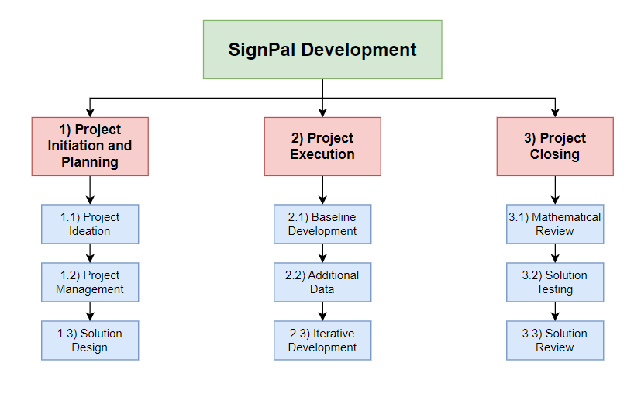

**Task Breakdown and Prioritization:**

Furthermore, work is then broken down into smaller tasks, that are more easily tackled by group members.

|  |  |  |  |
| --- | --- | --- | --- |
| **Mission** | **Phase** | **Tasks** | **Priority** |
| Project Ideation | Project Initiation | 1. Write problem statement. 2. Write motivation behind problem. 3. Discuss existing solutions in real world. 4. Draw up outline of the projects plan | High |
| Project Management | Project Planning | 1. Draw up code of conduct. 2. Draw up team member’s skills audit. 3. Conduct risk analysis of project. 4. Conduct task management. 5. Set schedule for project with deliverables. 6. Continuous progress and communication logging. | High |
| Solution Design | Project Planning | 1. Elicit requirements for proposed solution. 2. Draw up diagram for proposed solution. 3. Describe the proposed solution. 4. Describe the dataset that will be utilized. 5. Write down reasonings behind the development of proposed solution. | High |
| Baseline Development | Project Execution | 1. Prepare initial version of dataset used. 2. Develop and implement initial version of solution. 3. Evaluate initial solution. 4. Set up environment to be able to run code. | Medium |
| Additional Data | Project Execution | 1. Add datasets beyond data initially specified. 2. Give reasonings for the addition of new dataset. 3. Discuss methods used to prepare and integrate new datasets. 4. Produce an impact report discussing the impact of additional data on solution. | Medium |
| Iterative Development | Project Execution | 1. Evaluate several data pre-processing techniques. 2. Evaluate and compare models. 3. Justify parameters and tuning methods used. 4. Produce reproducible code of solution. | High |
| Mathematical Review | Project Closing | 1. Formulate problem mathematically. 2. Draw up mathematical justification for the proposed solution. 3. Draw up mathematical justification for the parameter choices. | Medium |
| Solution Testing | Project Closing | 1. Create testing plan. 2. Specify test cases. 3. Perform tests on solution. 4. Write report on tests. 5. Come up with recommendations for solution based on testing. | Medium |
| Solution Review | Project Closing | 1. Compare solution with existing solutions. 2. Justify comparisons found. 3. Come up with recommendations for solution based on comparisons. | High |

**Mission Dependency:**

Moving on, mission dependencies are logical relationships between all the missions in the project. It is essential to know the dependencies between missions as it gives an insight onto the project timeline and how a project can be delayed if a certain mission wasn’t completed on time.

|  |  |  |
| --- | --- | --- |
| **Mission (A)** | **Depends on (B)** | **Dependency type** |
| Project Ideation | N/A | N/A |
| Project Management | N/A | N/A |
| Solution Design | Project Ideation | Finish-to-start |
| Baseline Development | Solution Design, Project Ideation | Finish-to-finish |
| Additional Data | Solution Design, Baseline Development | Finish-to-finish |
| Iterative Development | Baseline Development, Additional Data, Solution Design, Project Ideation, Project Management | Start-to-start |
| Mathematical Review | Solution Design, Iterative Development | Finish-to-start |
| Solution Testing | Iterative Development | Finish-to-start |
| Solution Review | Iterative Development, Solution Testing | Finish-to-start |

Finish-to-start *(B must finish before A can start)*

Finish-to-finish *(B must finish before A can finish)*

Start-to-start *(B must start before A can start)*

Start-to-finish *(B must start before A can finish)*

**PERT Dependency Diagram:**

*Direction of Dependency: dependent mission is pointed to by mission that is depended on.

(eg. Solution Review pointed to by Iterative Development, meaning Solution Review depends on Iterative Development)

**Change Log:**

|  |  |  |
| --- | --- | --- |
| Date | Change | Impact |
| 25/3/2023 | Change mathematical review and additional data to be done simultaneously. | Increase iterative development from 16 days to 28 days. |
| 27/3/2023 | Change mathematical review to be done after iterative development. | No timeline changes. |
| 26/4/2023 | Changed Solution Review to be done after Solution Testing. | Solution Testing and Solution Review shortened to 5 days each. |

**Master Schedule:**

**Milestones and deliverables (version 1):**

|  |  |  |  |  |
| --- | --- | --- | --- | --- |
| **Missions** | **Start Date** | **Duration** | **End Date** | **Deliverables** |
| Project Ideation | 13/3/2023 | 4 days | 16/3/2023 | Project Ideation Document |
| Project Management | 13/3/2023 | 40 days | 5/5/2023 | Project Management Document |
| Solution Design | 16/3/2023 | 5 days | 20/3/2023 | Solution Design Document |
| **End of project initiation and planning** | | | **20/3/2023** |  |
| Baseline Development | 20/3/2023 | 7 days | 27/3/2023 | Initial version of solution |
| Mathematical Review | 27/3/2023 | 5 days | 31/3/2023 | Mathematical Review Document |
| Additional Data | 31/3/2023 | 8 days | 7/4/2023 | Additional Data Document |
| Iterative Development | 7/4/2023 | 22 days | 28/4/2023 | Final version of solution |
| **End of project execution** | | | **28/4/2023** |  |
| Solution Testing | 28/4/2023 | 5 days | 4/5/2023 | Solution Testing Document |
| Solution Review | 28/4/2023 | 5 days | 4/5/2023 | Solution Review Document |
| **End of project closing** | | | **4/5/2023** |  |
| **Submission of project** | | | **7/5/2023** |  |

**GANTT chart (version 1):**

**Milestones and deliverables (version 2):**

|  |  |  |  |  |
| --- | --- | --- | --- | --- |
| **Missions** | **Start Date** | **Duration** | **End Date** | **Deliverables** |
| Project Ideation | 13/3/2023 | 4 days | 16/3/2023 | Project Ideation Document |
| Project Management | 13/3/2023 | 40 days | 5/5/2023 | Project Management Document |
| Solution Design | 16/3/2023 | 5 days | 20/3/2023 | Solution Design document |
| **End of project initiation and planning** | | | **20/3/2023** |  |
| Baseline Development | 20/3/2023 | 8 days | 27/3/2023 | Initial version of solution |
| Mathematical Review | 27/3/2023 | 5 days | 31/3/2023 | Mathematical Review Document |
| Additional Data | 27/3/2023 | 5 days | 31/3/2023 | Additional Data Document |
| Iterative Development | 1/4/2023 | 28 days | 28/4/2023 | Final version of solution |
| **End of project execution** | | | **28/4/2023** |  |
| Solution Testing | 28/4/2023 | 7 days | 4/5/2023 | Solution Testing Document |
| Solution Review | 28/4/2023 | 7 days | 4/5/2023 | Solution Review Document |
| **End of project closing** | | | **4/5/2023** |  |
| **Submission of project** | | | **7/5/2023** |  |

**GANTT chart (version 2):**

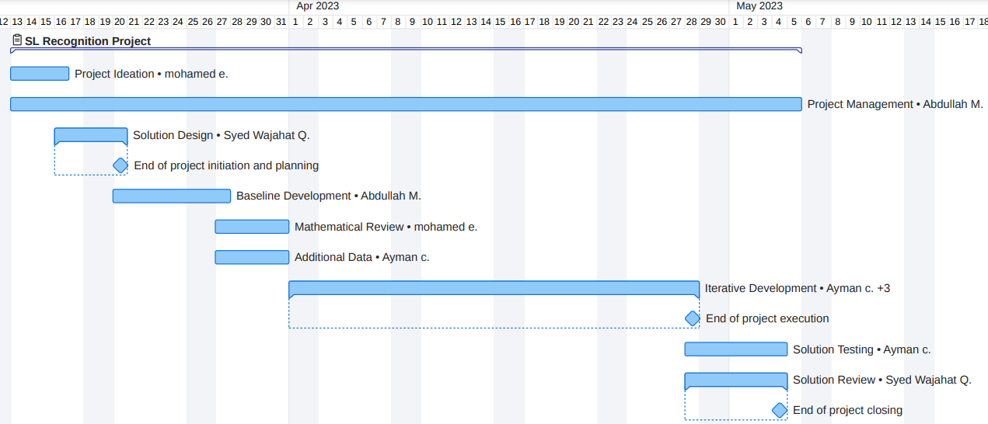**Milestones and deliverables (version 3):**

|  |  |  |  |  |
| --- | --- | --- | --- | --- |
| **Missions** | **Start Date** | **Duration** | **End Date** | **Deliverables** |
| Project Ideation | 13/3/2023 | 4 days | 16/3/2023 | Project Ideation Document |
| Project Management | 13/3/2023 | 40 days | 5/5/2023 | Project Management Document |
| Solution Design | 16/3/2023 | 5 days | 20/3/2023 | Solution Design Document |
| **End of project initiation and planning** | | | **20/3/2023** |  |
| Baseline Development | 20/3/2023 | 8 days | 27/3/2023 | Initial version of solution, Baseline Solution Document |
| Additional Data | 27/3/2023 | 5 days | 31/3/2023 | Additional Data Document, Additional Dataset |
| Iterative Development | 1/4/2023 | 28 days | 28/4/2023 | Final version of solution, Iterative Development Document |
| **End of project execution** | | | **28/4/2023** |  |
| Mathematical Review | 28/4/2023 | 7 days | 4/5/2023 | Mathematical Review Document |
| Solution Testing | 28/4/2023 | 7 days | 4/5/2023 | Solution Testing Document |
| Solution Review | 28/4/2023 | 7 days | 4/5/2023 | Solution Review Document |
| **End of project closing** | | | **4/5/2023** |  |
| **Submission of project** | | | **7/5/2023** |  |

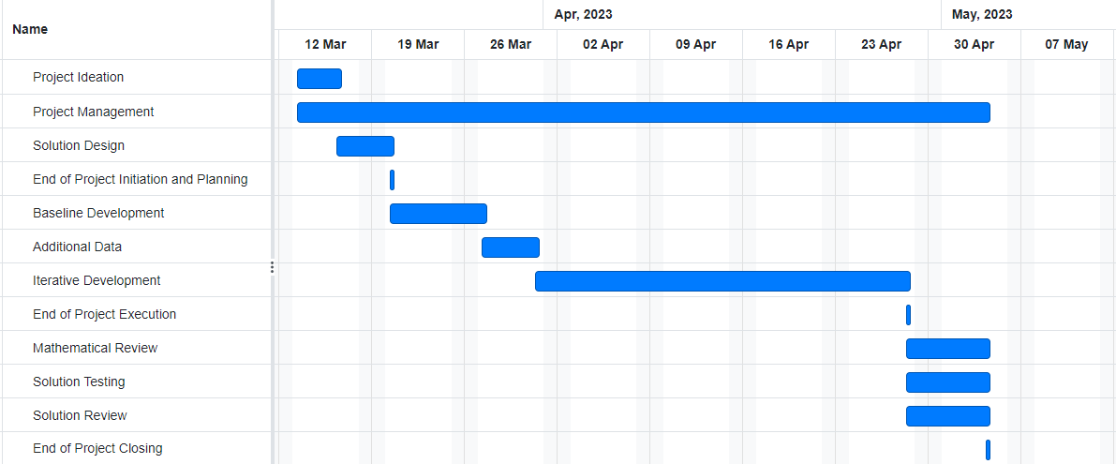**GANTT chart (version 3):**

**Milestones and deliverables (version 4):**

|  |  |  |  |  |
| --- | --- | --- | --- | --- |
| **Missions** | **Start Date** | **Duration** | **End Date** | **Deliverables** |
| Project Ideation | 13/3/2023 | 4 days | 16/3/2023 | Project Ideation Document |
| Project Management | 13/3/2023 | 41 days | 6/5/2023 | Project Management Document |
| Solution Design | 16/3/2023 | 5 days | 20/3/2023 | Solution Design Document |
| **End of project initiation and planning** | | | **20/3/2023** |  |
| Baseline Development | 20/3/2023 | 8 days | 27/3/2023 | Initial version of solution, Baseline Solution Document |
| Additional Data | 27/3/2023 | 5 days | 31/3/2023 | Additional Data Document, Additional Dataset |
| Iterative Development | 1/4/2023 | 28 days | 28/4/2023 | Final version of solution, Iterative Development Document |
| **End of project execution** | | | **28/4/2023** |  |
| Mathematical Review | 28/4/2023 | 7 days | 4/5/2023 | Mathematical Review Document |
| Solution Testing | 28/4/2023 | 5 days | 2/5/2023 | Solution Testing Document |
| Solution Review | 2/5/2023 | 5 days | 6/5/2023 | Solution Review Document |
| **End of project closing** | | | **6/5/2023** |  |
| **Submission of project** | | | **7/5/2023** |  |

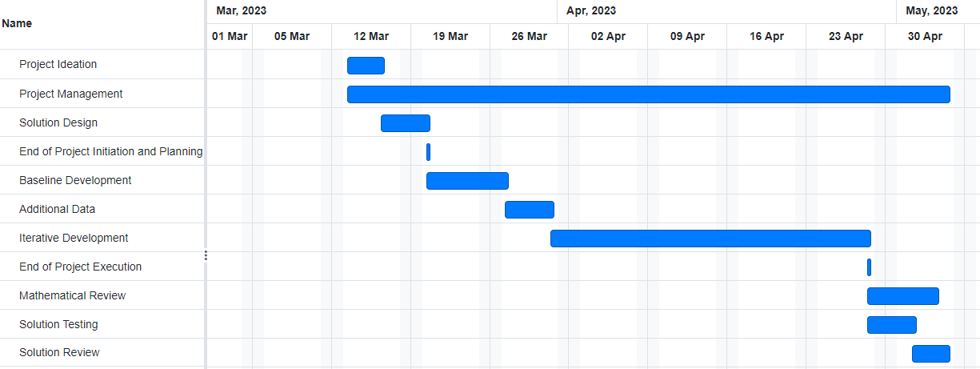**GANTT chart (version 4):**

**Progress Report:**

**First Group Meeting:** 08/02/2023

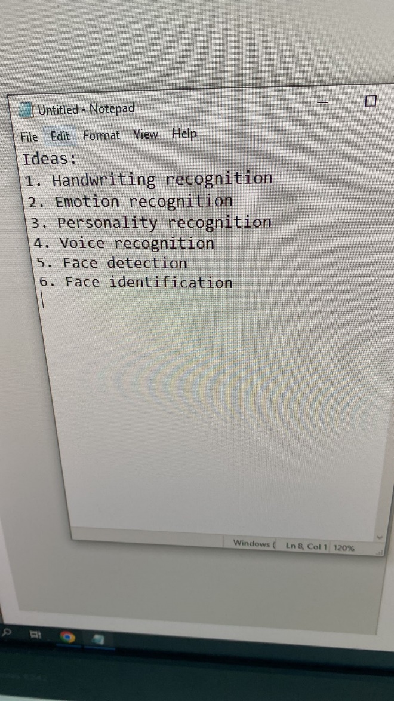Group met together to discuss and go through the software engineering practice umbrella and AI assessment briefs. Both documents were read and understood by all members of the group, and some brainstorming was done in choosing an AI problem to tackle and initial missions were decided by group members in a fair fashion. Some issues did arise due to confusion in the assessment briefs where we were unsure whether baseline development was an individual or group responsibility.

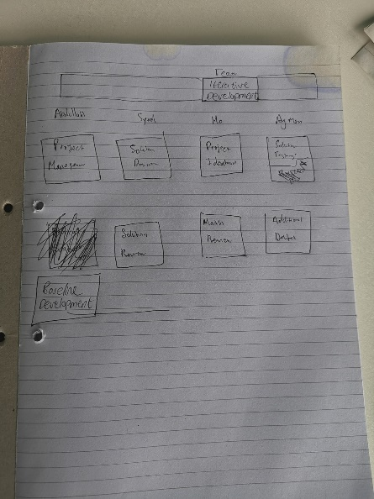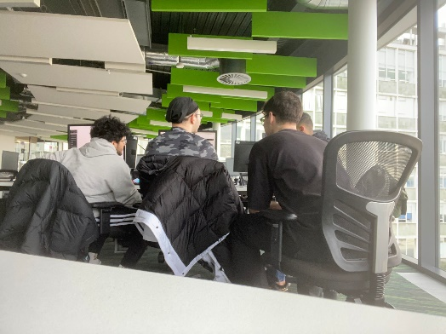

**Confirming Missions:** 13/02/2023

After gaining some clarity with the previous concerns by talking to a member of the teaching staff regarding some missions, the group has decided and finalized the missions and responsibilities of each person. Furthermore, the group has decided to base our project on the idea of handwriting recognition.

|  |  |  |  |
| --- | --- | --- | --- |
| Abdullah | Syed | Mohamed E. | Mohammed C. |
| Iterative Development | | | |
| Project Management | Solution Design | Project Ideation | Solution Testing |
| Baseline Development | Solution Review | Mathematical Review | Additional Data |

**Submission of skills audit and proposal:** 16/02/2023

After receiving skills audits from each member of the group, group manager merged all audits into one document and provided a brief summary on the skillsets of the group.

**Initial Idea Rejected:** 01/03/2023

After reviewing the idea with teaching staff, we were told that the initial project was not complex enough.

**Final Idea Confirmation:** 07/03/2023

The group has discussed and brainstormed new ideas to come up with an idea of developing software to recognize sign language and output the translation in text. The idea was then confirmed with teaching staff.

**Beginning of work:** 13/03/2023

After idea confirmation, work has begun on the project ideation mission as well as the project management mission.

**Project Management Document Shared:** 15/03/2023

After the initial version of the project management document being completed containing task breakdown and mission scheduling, document was shared with group members via GitHub.

**Solution Design Document Completed:** 20/03/2023

After the completion of the project ideation and the initial version of the project management document, The solution design document was completed and shared on GitHub. All work on schedule so far.

**Change in scheduling #1:** 25/03/2023

To be more efficient with our time, the mathematical review and additional data missions are now changed to be done simultaneously, this has lead to more time being available for the iterative development of the solution.

**Baseline Development Complete:** 26/03/2023

After having the outline of the solution from the project ideation and solution design documents, the baseline code was completed and shared on GitHub, alongside the baseline documentation. Slightly ahead of schedule.

**Insert Group Meeting Image Here**

**Change in scheduling #2:** 27/03/2023

After some slight misunderstanding of the missions and between team members, mathematical review has been changed to be completed after the iterative development mission (after the solution has been complete).

**Additional Data Complete:** 31/03/2023

Additional data documentation alongside the additional dataset has been complete and shared on GitHub to other group members.

**Insert Group Meeting Image Here**

**Beginning of Work on Iterative Development:** 01/04/2023

After having a baseline solution and additional datasets ready, work has begun on producing a more complex and accurate solution.

**Iterative Development Interface Complete:** 08/04/2023

Interface part of the solution has been completed and is fully functional.

**Initial Version of Solution Complete:** 13/04/2023

Solution has been completed but there are various deficiencies in the solution, slow run-time and inaccuracy being major issues.

**Insert Group Meeting Image Here**

**Solution Refining:** 13/04/2023 – 18/04/2024

Attempts to make model more accurate, making a clearer dataset, change epochs used etc.

**Solution Complete:** 25/04/2023

The program has been completed, is running without any issues with good levels of accuracy. Slightly ahead of schedule.

**Insert Group Meeting Image Here**

**Beginning of work on Mathematical Review, Solution Testing, Solution Review:** 27/04/2023

As the group is ahead of schedule, work has begun on the remaining 3 missions.

**All missions completed:** 04/05/2023.

All members have successfully completed their missions, and files shared on GitHub. Solution is also completed and is functioning as intended.

**Project Submitted:** 07/05/2023.

As scheduled, work has been submitted on the seventh of May.

**References**

Campbell, G.M. (2014). *8 Managing Risks and Constraints - Project Management, Sixth Edition [Book]*. [online] oreilly.com. Available at: https://learning.oreilly.com/library/view/project-management-sixth/9781615644421/xhtml/chapter008.xhtml#p26 [Accessed 13 Mar. 2023].

A Guide To The Project Management Body of Knowledge. (2008). Available at: https://www.works.gov.bh/English/ourstrategy/Project%20Management/Documents/Other%20PM%20Resources/PMBOKGuideFourthEdition_protected.pdf [Accessed 13 Mar. 2023].

Project Management Institute. (n.d.). *Risk analysis and management*. [online] Available at: https://www.pmi.org/learning/library/risk-analysis-project-management-7070 [Accessed 13 Mar. 2023].